AWS CLOUD COMPUTING CA 1

Reg no: 727721euit003

Name: ABINESH K

**Question 1**

Give the name tag of both server and key pair as “ec2usecase2”(NAME)

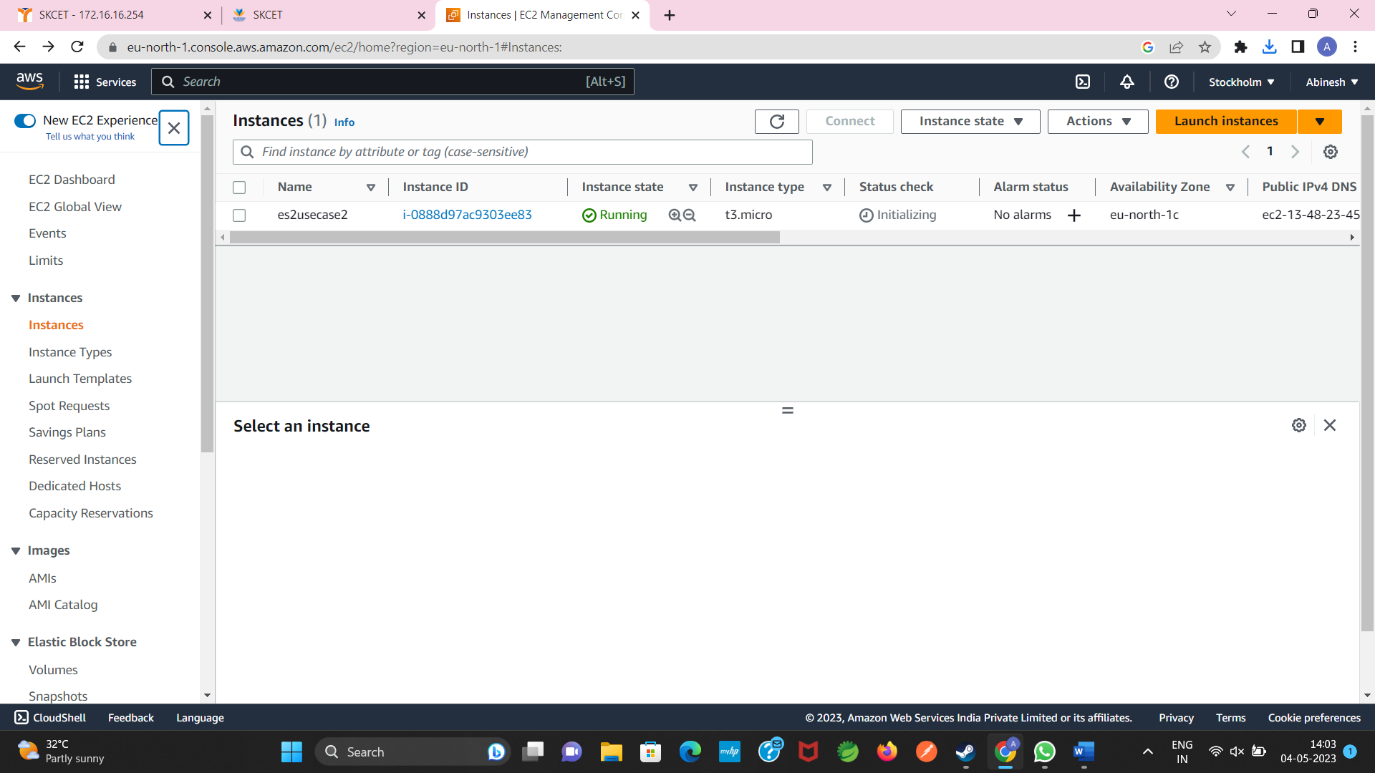

Select the AMI from the amazon linux os platform

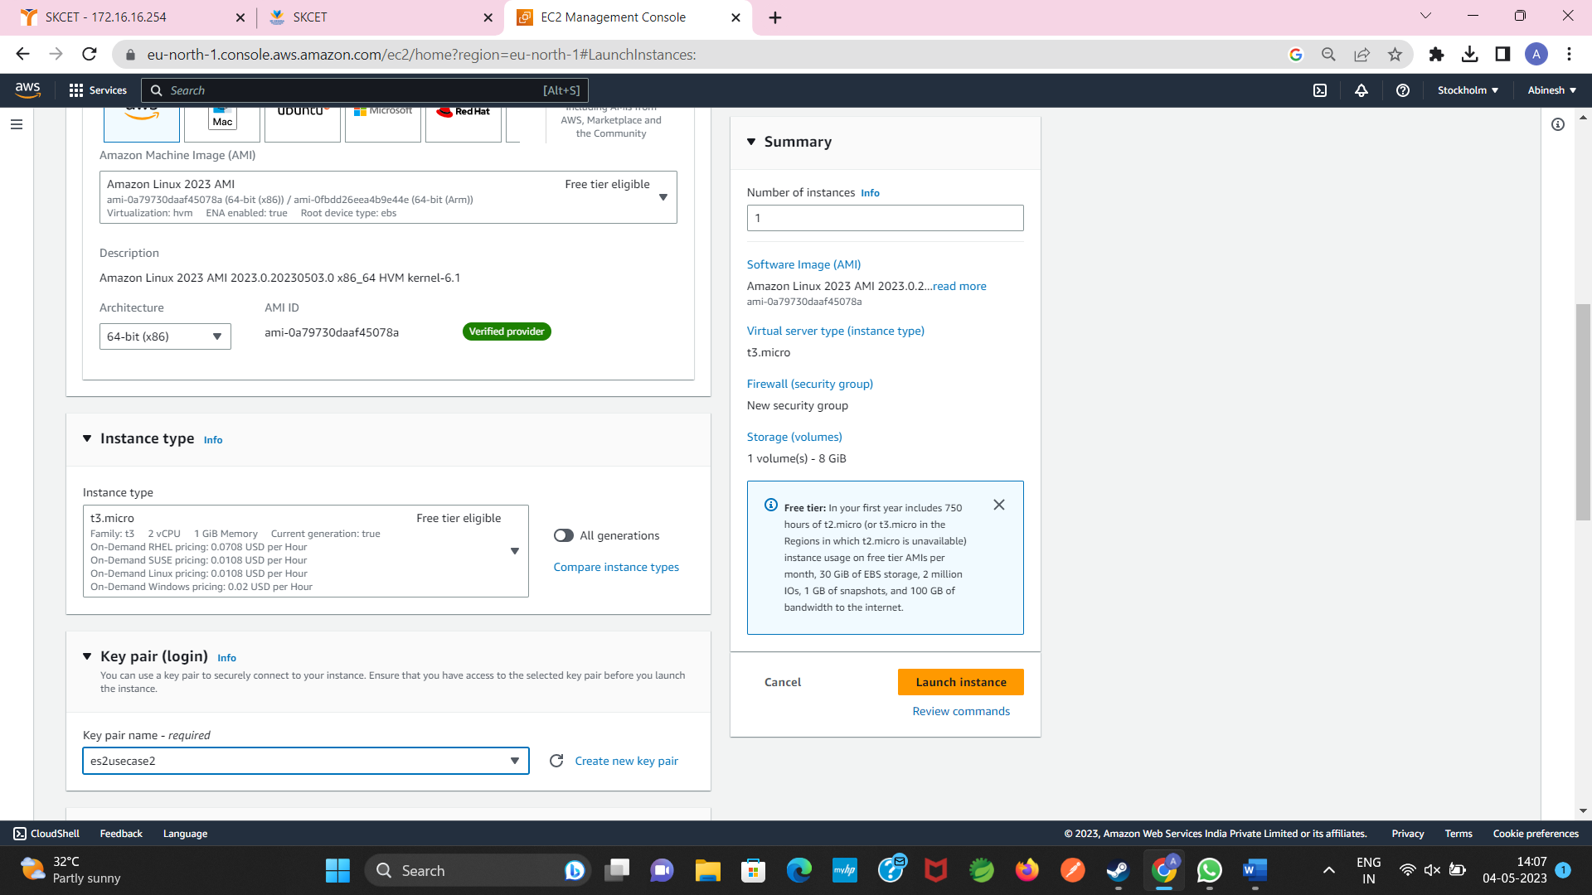

Increase the root EBs volume size to 10 GB from the default size

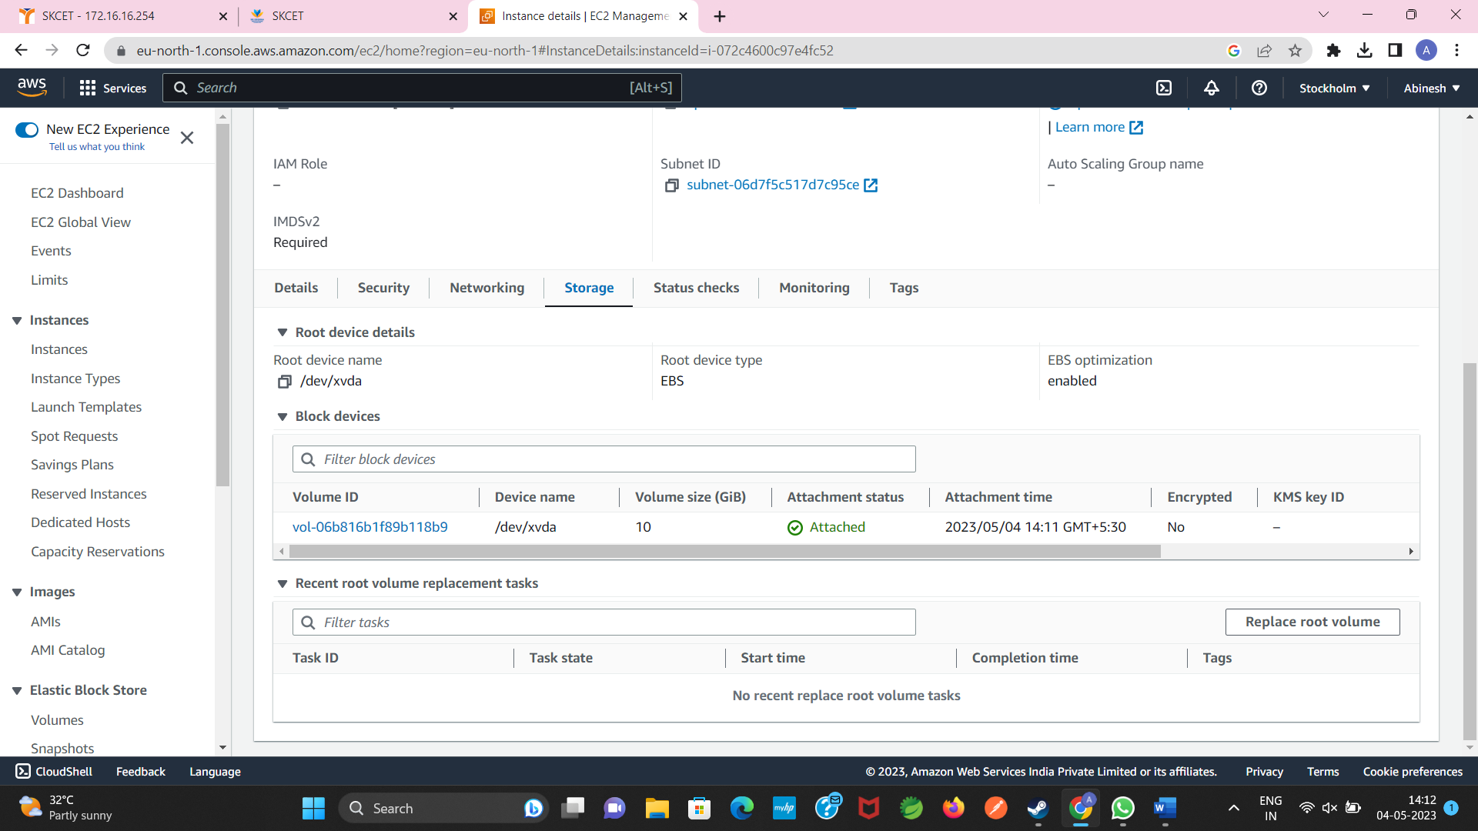

Expose port no.22 for taking putty connection

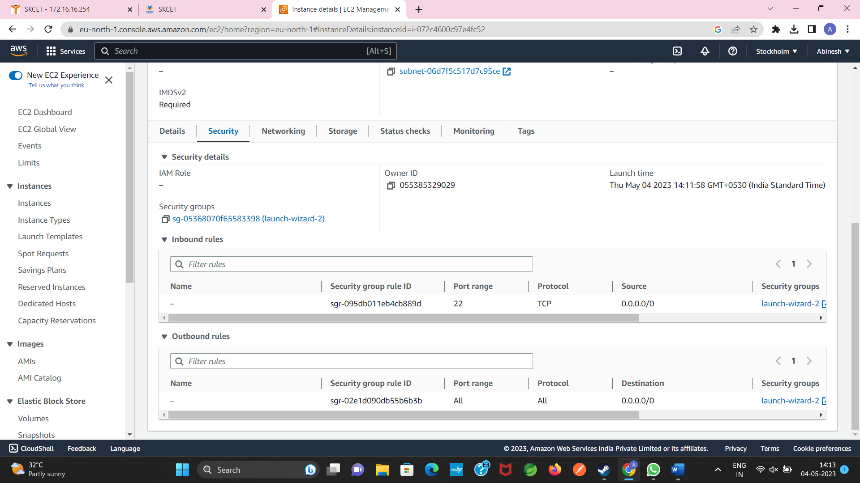

**Question 2**

Give the name tag of both server and key pair as “ec2usecase1”(NAME)

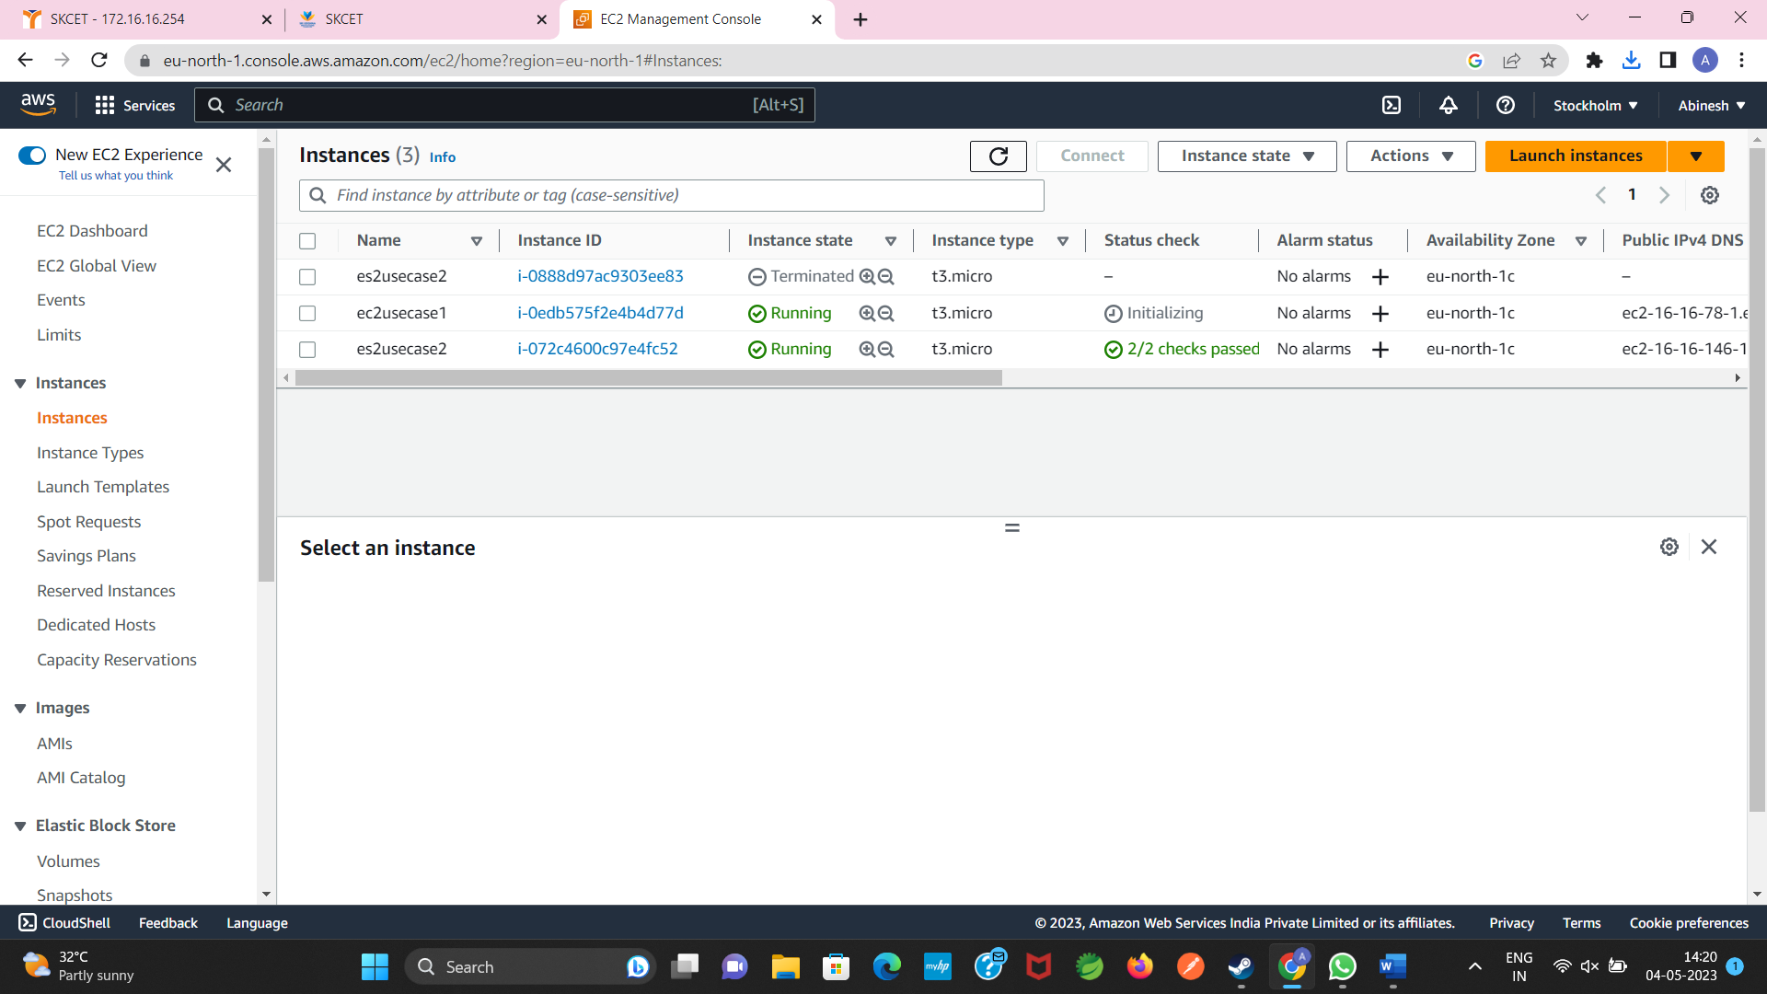

Select the AMI from the amazon Windows os platform

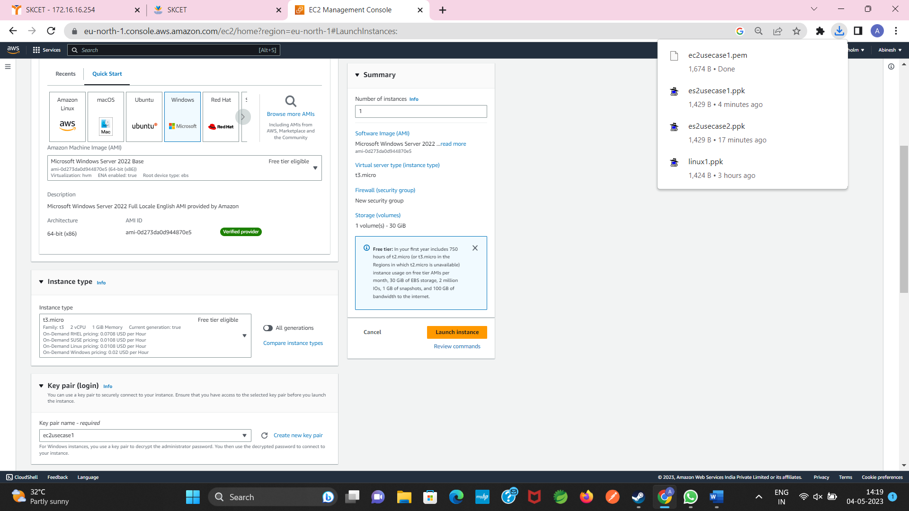

Ensure the Auto -Assaigned public -IP must be enabled

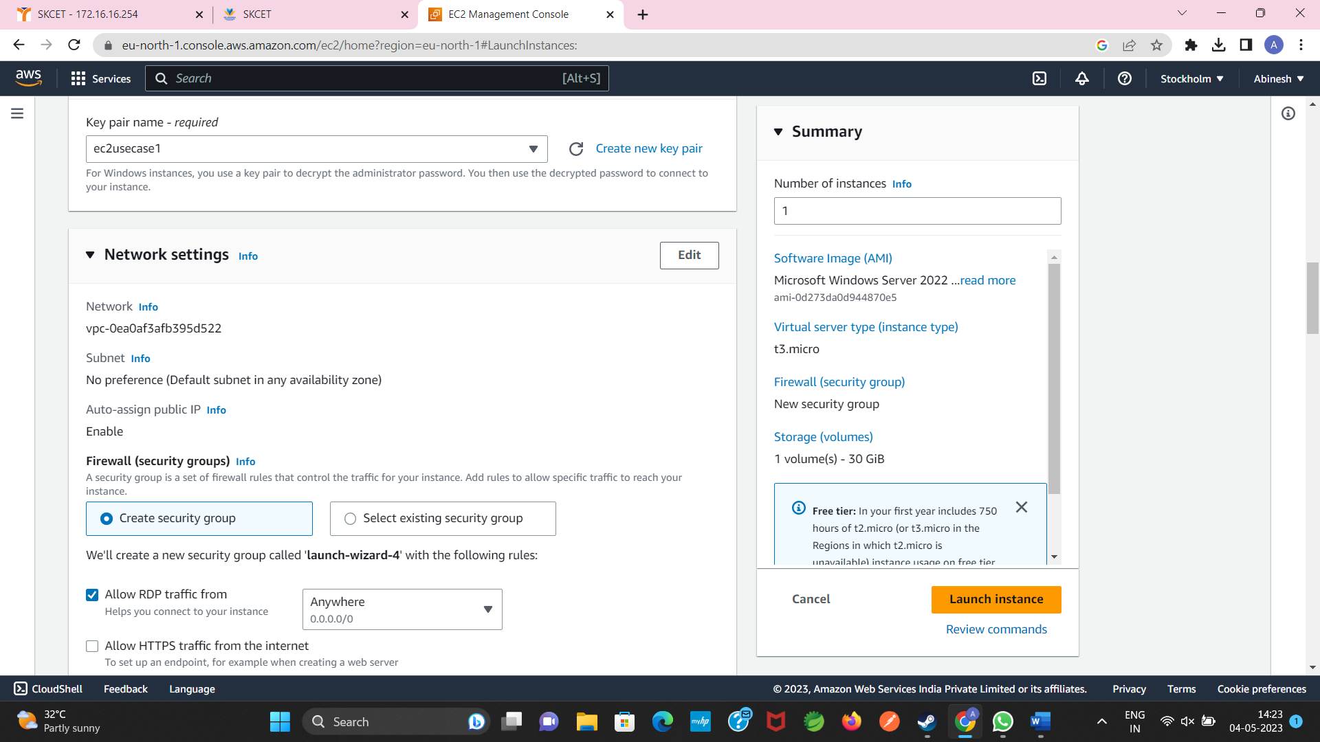

Expose port no.3389 for taking the remote desktop connection

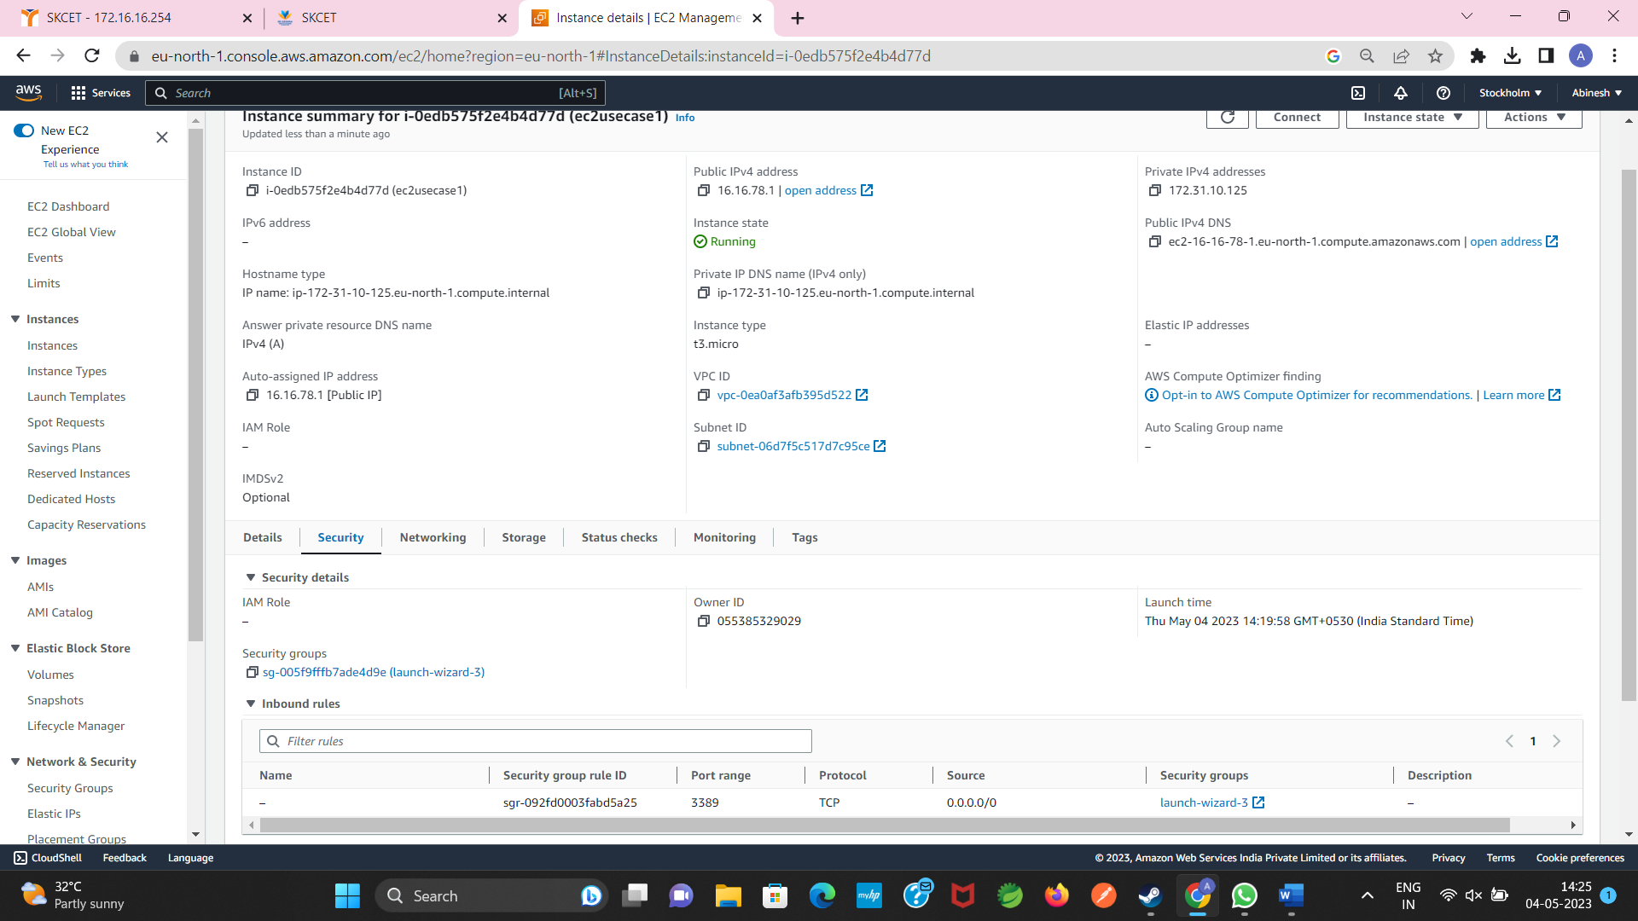

**Question 3**

i)

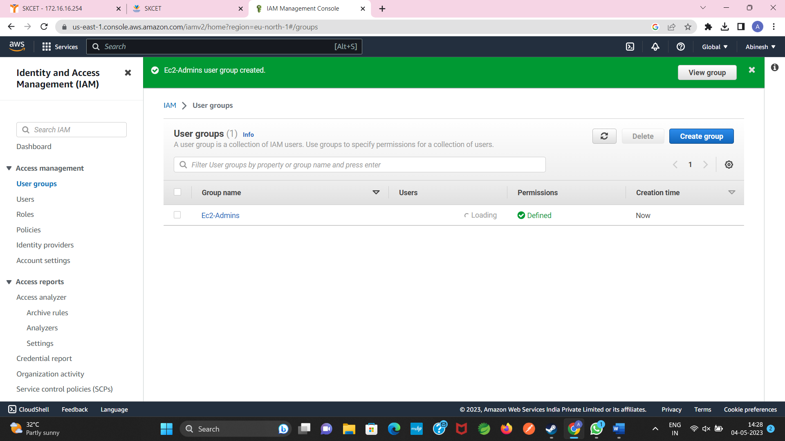

ii)

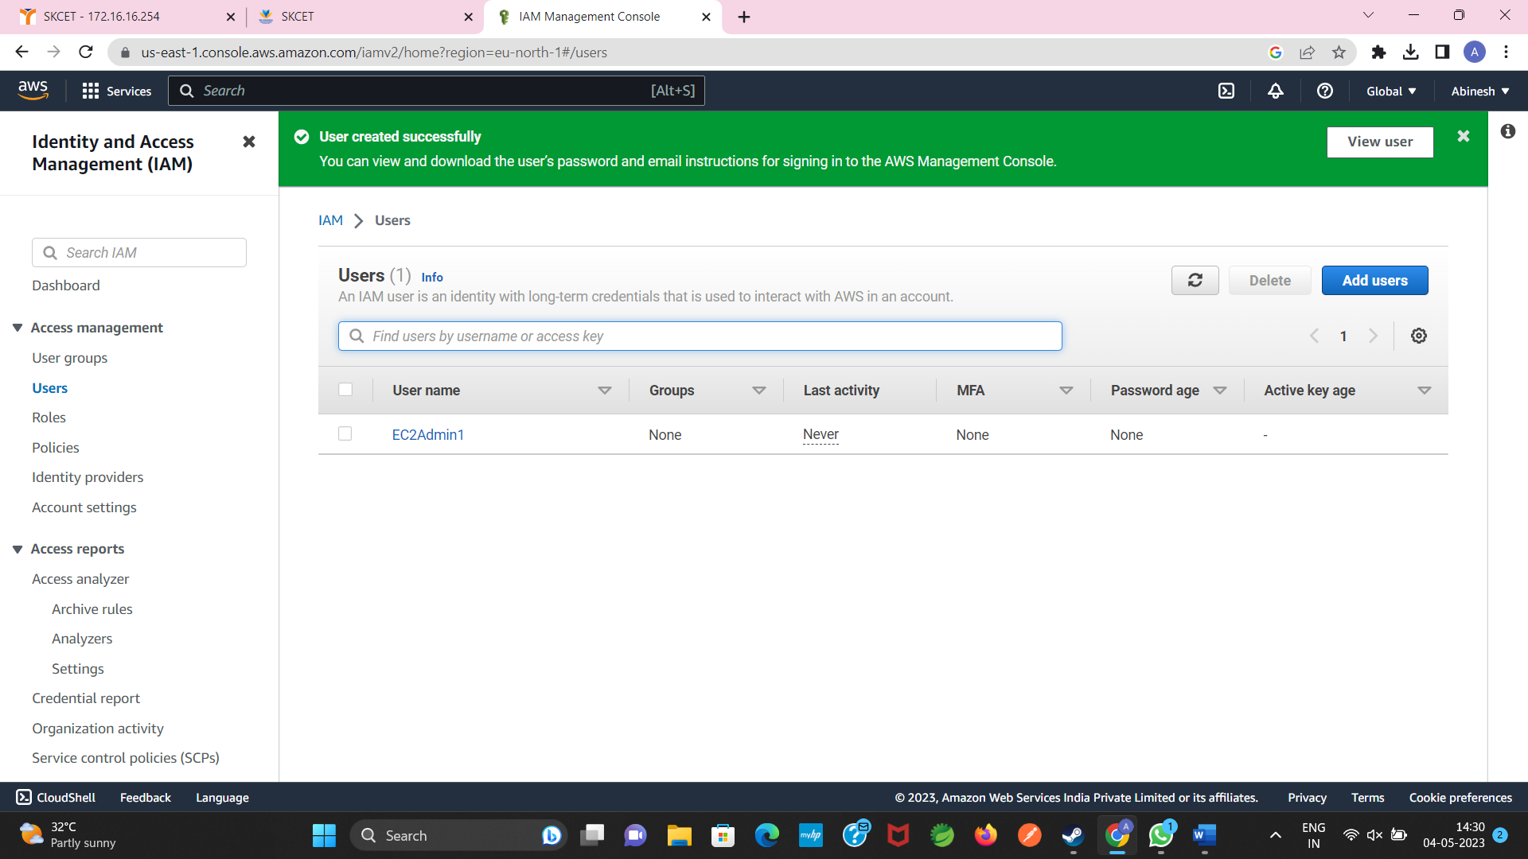

iii)

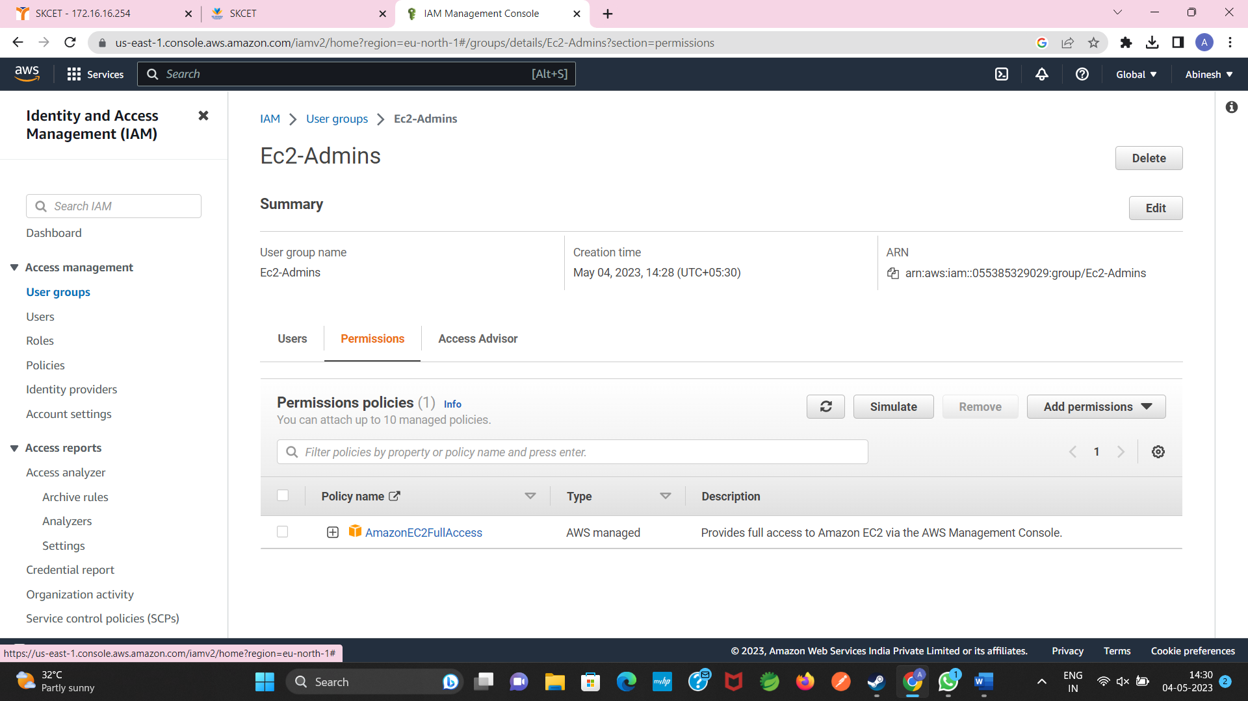

iv)

